

**Subject**

**Software Design and Architecture**

**Project Phase II**

**Topic**

**Shapper (A task Manager)**

Submitted By:

|  |  |
| --- | --- |
| Names | Roll No |
| Noor Fatima | 22F-3634 |
| Zainab Eman | 22F-3738 |
| Imama Kainat | 22F-3661 |

**Submitted To: Submission Date:**

Sajid Anwar 14/05/2024

## 

## **Main functionalities of shapper**

**Manage Tasks**

* Create Task
* View Task List
* Update Task
* Delete Task

**Set Task Details**

* Set Priority
* Add Tags
* Attach Files

**Task Scheduling and Resource Allocation**

* Create Project
* Monitor Progress

## **Requirements**

### **Manage Tasks:**

#### **Create Task**

1. Take Task name, description, due date, priority level, and other optional details (e.g., tags, categories).
2. Validate input, create a new task with a unique identifier, and store it in the database.
3. Confirmation message indicating successful task creation.

#### **View Task List**

1. When user request to view tasks, Retrieve the user's tasks from the database.
2. Display a list of tasks with details like task name, due date, and priority level.

#### **Update Task**

1. User will select the task from the displayed tasks, details of that task should be shown on the screen
2. When the user select update option, The edit mode should open
3. User will update the details, like name , due date, priority
4. System will validate the updated data to maintain data integrity and save the task
5. A successful updating message should be shown after the process

#### **Delete Task**

1. User will select the task from the displayed tasks
2. user select delete option
3. Remove that task from the database.
4. Confirmation message indicating the task has been deleted.

#### **Set Task Details:**

1. User can set detail by add priority (can be in form of number, colors etc.), can add tags and attach a file or document (image, word, pdf, excel sheet etc.)
2. The system will save the updates and show a confirmation message

### **Task Scheduling and Resource Allocation**

#### **Create Project:**

1. Project Manager can creates a new project within the app.
2. Project manager can add project name, description, start date, end date, and assigned team members.
3. Project Manager can defines more details of the task such as, description, estimated duration, priority, dependencies and required resources
4. Project Manager can assign start and end dates to tasks
5. Project Manager assigns tasks to team members based on their roles, skills, and workload capacity.
6. Team members receive notifications or task assignments within the app.

#### **Monitor Progress:**

1. Team members update task progress regularly within the app, indicating completed, in progress, or delayed tasks.
2. Project Manager monitors overall project progress tracking.

### **Constraints**

**Resource Availability**

* Provide a dashboard showing each team member's workload, availability, and scheduled time off.
* Set up automatic alerts for over allocated resources or scheduling conflicts.
* Use an algorithm to balance task assignments based on workload and availability.

**Task Dependencies**

* Allow users to define and visualize dependencies between tasks with an interactive dependency graph or Gantt chart.
* When a preceding task is delayed, automatically adjust the schedules of dependent tasks and notify the relevant stakeholders.
* Provide alerts or notifications when a task that has dependencies is at risk of not meeting its deadline.

**Time Constraints**

* Send deadline alerts and reminders to keep team members informed.
* Use dynamic scheduling to adjust timelines based on progress updates and changing priorities.
* Track critical milestones and highlight risks to meeting them on time.

**Priority Conflicts**

* Implement clear task prioritization with visual cues like color codes or a matrix.
* Enable dynamic reprioritization with clear communication to stakeholders.
* Provide conflict resolution suggestions and allow quick adjustments to priorities and resource allocation.

## **Use case Diagram**

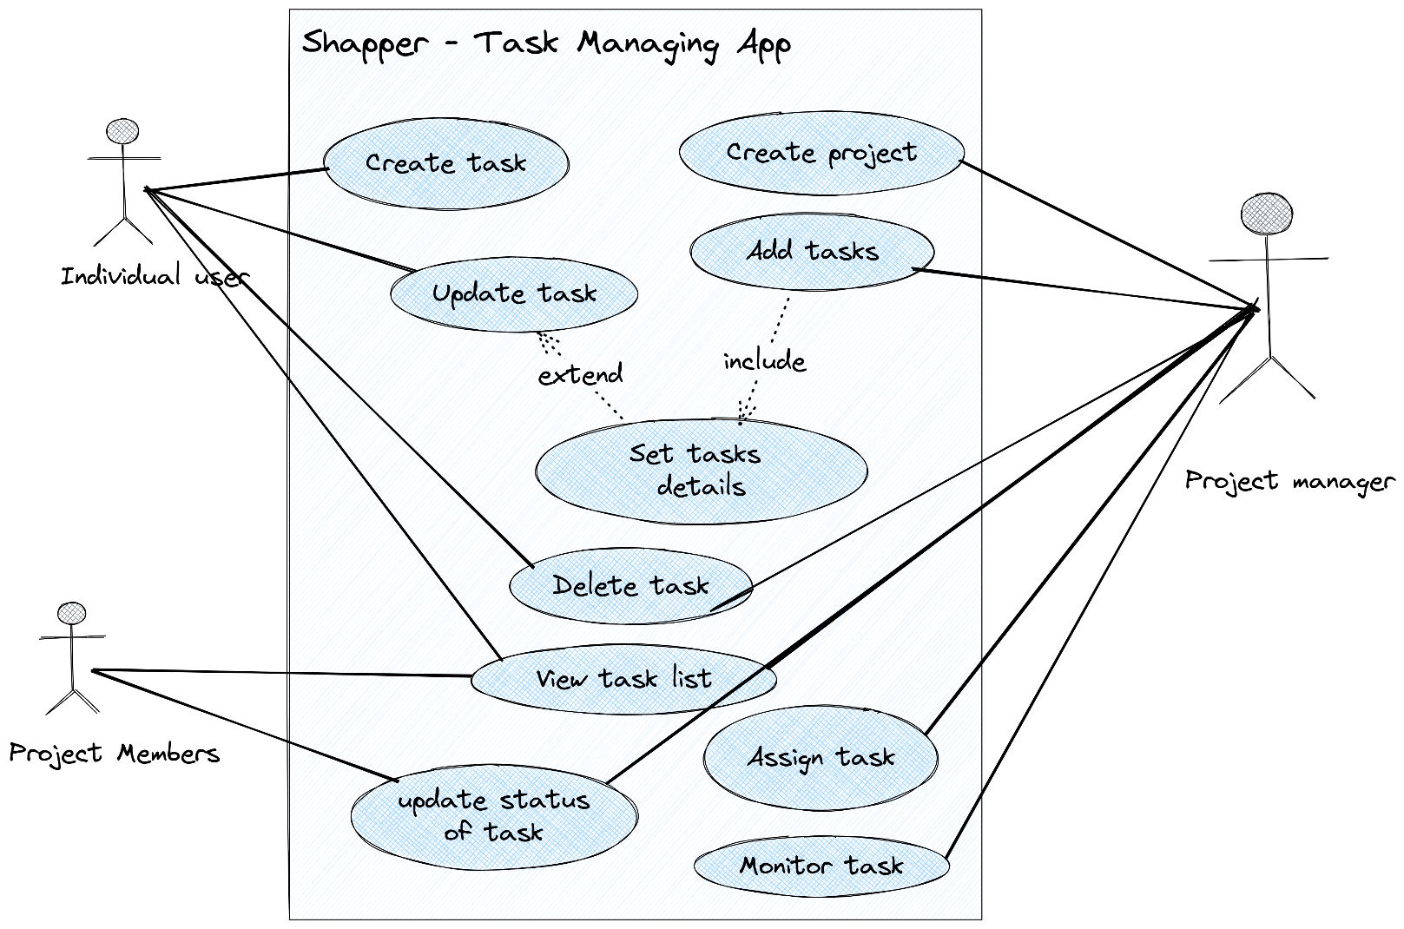

## **Use Case –Specification**

### **Create Task**

|  |  |
| --- | --- |
| Use case name: | Create Task |
| Scenario: | User Want to add a task |
| Brief Description: | Allows the user to create a new task with specific details. |
| Actor: | User, System |
| Related Use Case: | No use case related |
| Pre-conditions: | User must be logged in with necessary permissions. |
| Post conditions: | A new task is created and stored in the system. |
| Flows Activities: | 1. User selects the option to create a new task. 2. User inputs task details (name, description, due date, priority). 3. System validates and saves the task. 4. User receives a confirmation message. |
| Exception condition: | If input validation fails, the system displays an error and prompts the user to correct the details |
| Alternative Flows | Not applicable. |

### **View Task List**

|  |  |
| --- | --- |
| Use case name: | View Task List |
| Scenario: | User views a list of their tasks. |
| Brief Description: | Users can view all their tasks listed with relevant details. |
| Actor: | User, Project manager, project members, System |
| Related Use Case: | No use case related |
| Pre-conditions: | User is logged in. |
| Post conditions: | User views a list of their tasks. |
| Flows Activities: | 1. User requests to view their task list. 2. System retrieves and displays the tasks. |
| Exception condition: | None |
| Alternative Flows | If no tasks exist, the system informs the user. |

### **Update Task**

|  |  |
| --- | --- |
| Use case name: | Update Task |
| Scenario: | User updates an existing task. |
| Brief Description: | User selects a task and modifies its details. |
| Actor: | User, Project Manager, System |
| Related Use Case: | Set Task Details |
| Pre-conditions: | User has selected a task they have permission to edit. |
| Post conditions: | The task is updated in the system. |
| Flows Activities: | 1. User selects a task and chooses to update it. 2. User modifies the task's details. 3. System validates and saves the changes. 4. User receives a confirmation message. |
| Exception condition: | None |
| Alternative Flows | If validation fails, prompt user to correct the input. |

### **Delete Task**

|  |  |
| --- | --- |
| Use case name: | Delete Task |
| Scenario: | User deletes an existing task. |
| Brief Description: | User selects a task and deletes it from the system. |
| Actor: | User, Project Manager, System |
| Related Use Case: | None |
| Pre-conditions: | User has selected a task they have permission to delete. |
| Post conditions: | he task is removed from the system. |
| Flows Activities: | 1. User selects a task and opts to delete it. 2. System confirms the action and deletes the task. 3. User receives a confirmation message. |
| Exception condition: | If the task cannot be deleted due to dependencies, inform the user. |
| Alternative Flows | Not applicable. |

### **Set Task Details**

|  |  |
| --- | --- |
| Name: | Set task details |
| Scenario: | User adds or updates details for a task. |
| Brief Description: | User can add or modify priority, tags, and attachments for a task. |
| Actor: | User, Project Manager, System |
| Related Use Case: | Update Task, Add Task |
| Pre-conditions: | User has selected a task to modify. |
| Post conditions: | The task details are updated in the system. |
| Flows Activities: | 1. User selects a task and chooses to add or modify details. 2. User adds/updates priority, tags, and attachments. 3. System saves the changes and confirms to the user. |
| Exception condition: | If saving fails, the user is informed. |
| Alternative Flows | Not applicable. |

### **Create Project**

|  |  |
| --- | --- |
| Use case name: | Create Project |
| Scenario: | Project Manager creates a new project. |
| Brief Description: | Project Manager inputs details to create a new project and assigns tasks. |
| Actor: | Project Manager, System |
| Related Use Case: | No use case related |
| Pre-conditions: | User identified as Project Manager is logged in. |
| Post conditions: | A new project is created and stored in the system. |
| Flows Activities: | 1. Project Manager inputs project details. 2. Project Manager adds tasks and assigns team members. 3. System validates and saves the project. 4. Team members are notified of their assignments. |
| Exception condition: | None. |
| Alternative Flows | If validation fails, prompt to correct input. |

### **Monitor Progress**

|  |  |
| --- | --- |
| Use case name: | Monitor Progress |
| Scenario: | Project Manager monitors the progress of tasks within a project. |
| Brief Description: | This use case allows the Project Manager to check the status and progress of various tasks and overall project advancement. |
| Actor: | Project Manager, System |
| Related Use Case: | No use case related |
| Pre-conditions: | The Project Manager is logged in and has selected a project to monitor. |
| Post conditions: | The Project Manager is updated with the latest progress information on the project and its tasks. |
| Flows Activities: | 1. Project Manager selects a project to monitor. 2. System displays the current progress of tasks and the overall project. 3. Project Manager reviews the progress information. 4. If necessary, the Project Manager takes action based on the progress (e.g., reallocating resources, adjusting timelines). |
| Exception condition: | If the system fails to retrieve or display progress information, it should notify the Project Manager of the error and suggest trying again later. |
| Alternative Flows | If there are no updates or changes in the project progress, the system informs the Project Manager accordingly. |

### **Update Task Status**

|  |  |
| --- | --- |
| Use case name: | Update Task Status |
| Scenario: | A team member updates the status of their assigned task. |
| Brief Description: | This use case allows a team member to change the status of a task they are assigned to, reflecting their progress on the task. |
| Actor: | Project Members, System |
| Related Use Case: | No use case related |
| Pre-conditions: | * The team member is logged in. * The team member has been assigned at least one task. |
| Post conditions: | * The status of the task is updated in the system. * Relevant stakeholders (e.g., Project Manager) are notified of the status change. |
| Flows Activities: | 1. The team member logs into the system and navigates to their list of assigned tasks. 2. The team member selects a task to update. 3. The team member changes the status of the task (e.g., from "In Progress" to "Completed"). 4. The system validates the update and saves the new status. 5. The system confirms the status update to the team member. 6. Notifications are sent to relevant stakeholders about the status change. |
| Exception condition: | If the system encounters an error while saving the task status (e.g., due to a network issue or database error), it should inform the team member of the error and suggest they try the update again later.. |
| Alternative Flows | If the team member selects a task that they are not permitted to update (e.g., a task not assigned to them), the system should display an appropriate message and disallow the status update. |
|  |  |

# **Architecture**

# Architecture Design:

Shapper adopts a layered architecture, offering a structured approach for higher business enterprise, maintainability, and scalability. Its patron-server architecture guarantees a continuing person experience, with the customer-side dealing with the dynamic presentation layer (UI) and the server-facet coping with the robust application common sense and records management.

The reason of using layer architecture :

Structured Approach: The layered architecture provides a clear and organized structure for the application, making it easier to understand, develop, and maintain. Each layer (presentation, application logic, data management) has its own set of responsibilities, leading to a more manageable codebase.

Higher Business Enterprise: By adopting a layered architecture, Shapper is better equipped to handle the complex needs of a business enterprise. The separation of concerns allows for more flexibility and adaptability to changing business requirements.

Maintainability: The layered architecture promote maintainability by separating different aspects of the application. This means that changes can be made to one part of the application without affecting the others, reducing the risk of introducing bugs and making it easier to debug and update the code.

Scalability: The layered architecture and client-server architecture enable Shapper to scale effectively. The application can handle increased load by adding more servers or scaling individual components as needed, without requiring a complete overhaul of the system.

Continuing User Experience: The client-server architecture ensures a seamless user experience by offloading resource-intensive tasks to the server, allowing the client-side to focus on presenting data and interacting with the user. This leads to a faster and more responsive application.

# Components:

User Interface Components: Shapper's UI boasts a range of elements for notice-taking, project tracking, file introduction, and collaboration capabilities. These components are designed to be modular and reusable, ensuring a constant and intuitive consumer revel in.

Application Logic Components: These additives energy the enterprise good judgment, processing person enter, handling statistics, and orchestrating interactions between special elements of the system.

Data Management Components: Responsible for the storage and retrieval of records, along with relational databases for dependent statistics and different storage answers for unstructured statistics, ensuring efficient information management.

Collaboration Components: Shapper's collaboration capabilities are pushed by additives for real-time communication, file sharing, and user permissions control, improving teamwork and productiveness.

# Connectors:

API Connectors: Shapper seamlessly integrates with outside APIs for services together with cloud garage, authentication, and communique equipment, enhancing its functionality and connectivity.

Database Connectors: These connectors have interaction with the underlying database system, permitting Create, Read, Update, Delete (CRUD) operations and green information management.

Event Connectors: Managing the flow of occasions among special components and services, making sure well timed and correct communique, and enhancing responsiveness.

# Architectural Pattern:

Shapper follows the Model-View-Controller (MVC) architectural sample, which separates the software into three interconnected components - the model (facts and enterprise good judgment), the view (presentation layer), and the controller (user enter and updates). This sample ensures a modular and maintainable codebase, with each thing specializing in a selected element of the utility.

The reason of using this pattern :

The MVC (Model-View-Controller) architectural pattern is utilized in software program improvement to split the worries of an software into three fundamental components: Model, View, and Controller. Each thing has a particular function and obligation, contributing to the general structure and capability of the software.

**Model:** The Model represents the software's data and business common sense. It is liable for dealing with the statistics, processing consumer enter, and responding to queries from the View and Controller. The Model guarantees that the utility's facts is accurate, up-to-date, and constant.

**View:** The View is chargeable for offering the information to the user in a consumer-friendly format. It shows the records from the Model to the user and captures consumer enter. The View does not contain any business good judgment and is handiest worried with the presentation of information.

**Controller:** The Controller acts as an middleman between the Model and the View. It gets user enter from the View, processes it (often by way of interacting with the Model), and updates the View for this reason. The Controller includes the software's good judgment for coping with user movements and updating the Model and View as important.

The motive of the MVC sample is to achieve separation of issues, which makes the software less difficult to increase, hold, and take a look at. By setting apart the software into those three components, developers can consciousness on one thing of the application at a time, while not having to fear about the opposite additives. This also permits for more flexibility and reusability of code, as every aspect can be modified or replaced with out affecting the others. Overall, the MVC pattern helps to create nicely-structured, modular, and maintainable applications.

# Architectural Styles:

Service-Oriented Architecture (SOA): Shapper employs SOA to interrupt down its capability into manageable services, enhancing improvement, preservation, and scalability.

Microservices: Utilizing microservices within the SOA, Shapper complements fault tolerance, scalability, and development cycles by breaking down the application into smaller, impartial offerings.

Component-Based Architecture: Shapper's UI is constructed using a factor-based architecture, taking into account modularization and reusability of UI factors, simplifying development, upkeep, and updates.

Client-Server Architecture: Shapper's purchaser-server architecture ensures pass-platform compatibility and centralized records management, presenting a constant person revel in throughout one-of-a-kind gadgets and systems.

Event-Driven Architecture: Shapper's occasion-driven structure enables real-time verbal exchange between offerings via activities, improving flexibility, scalability, and responsiveness.

In conclusion, Shapper's structure is designed to be modular, scalable, and flexible, providing a complete workspace answer for people, groups, and businesses, with a focus on improving productiveness and collaboration.

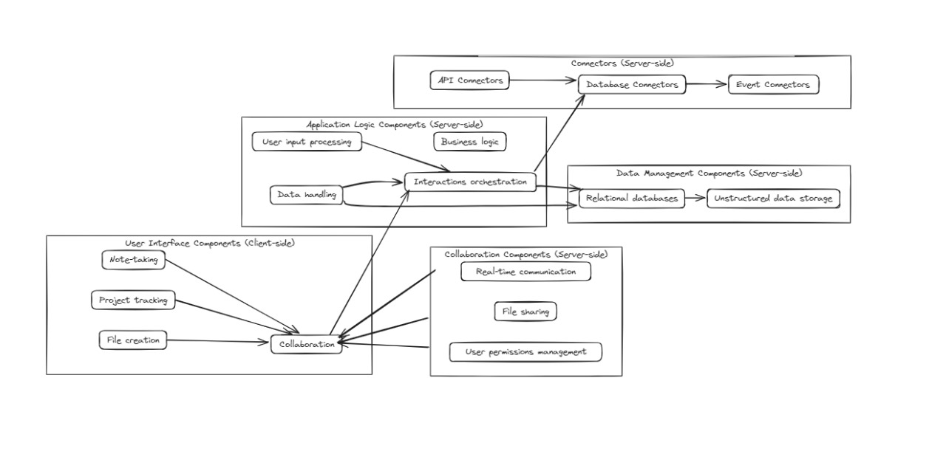

**Use Cases:**

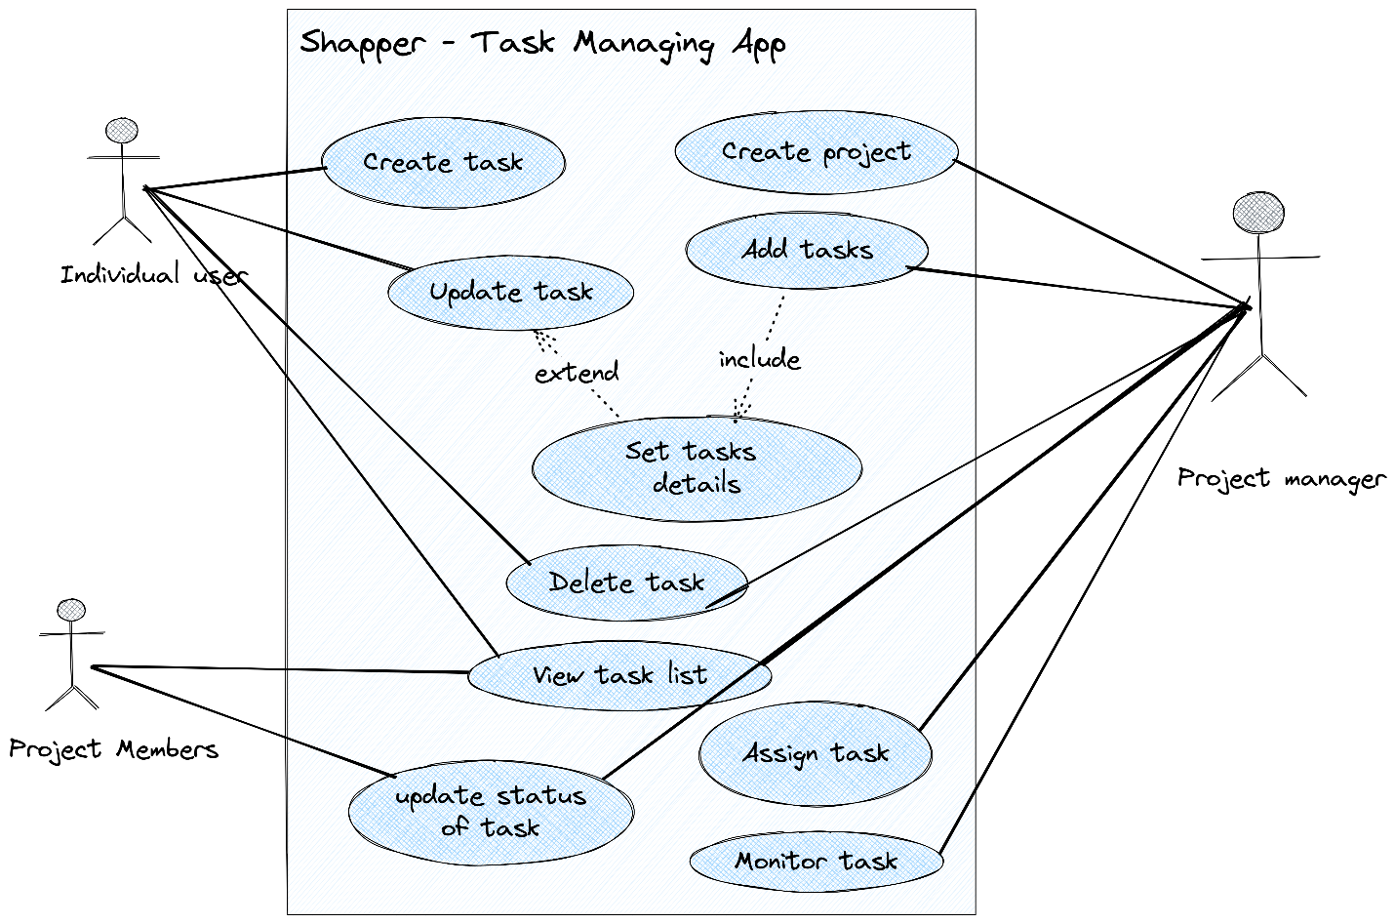

**Domain Model :**

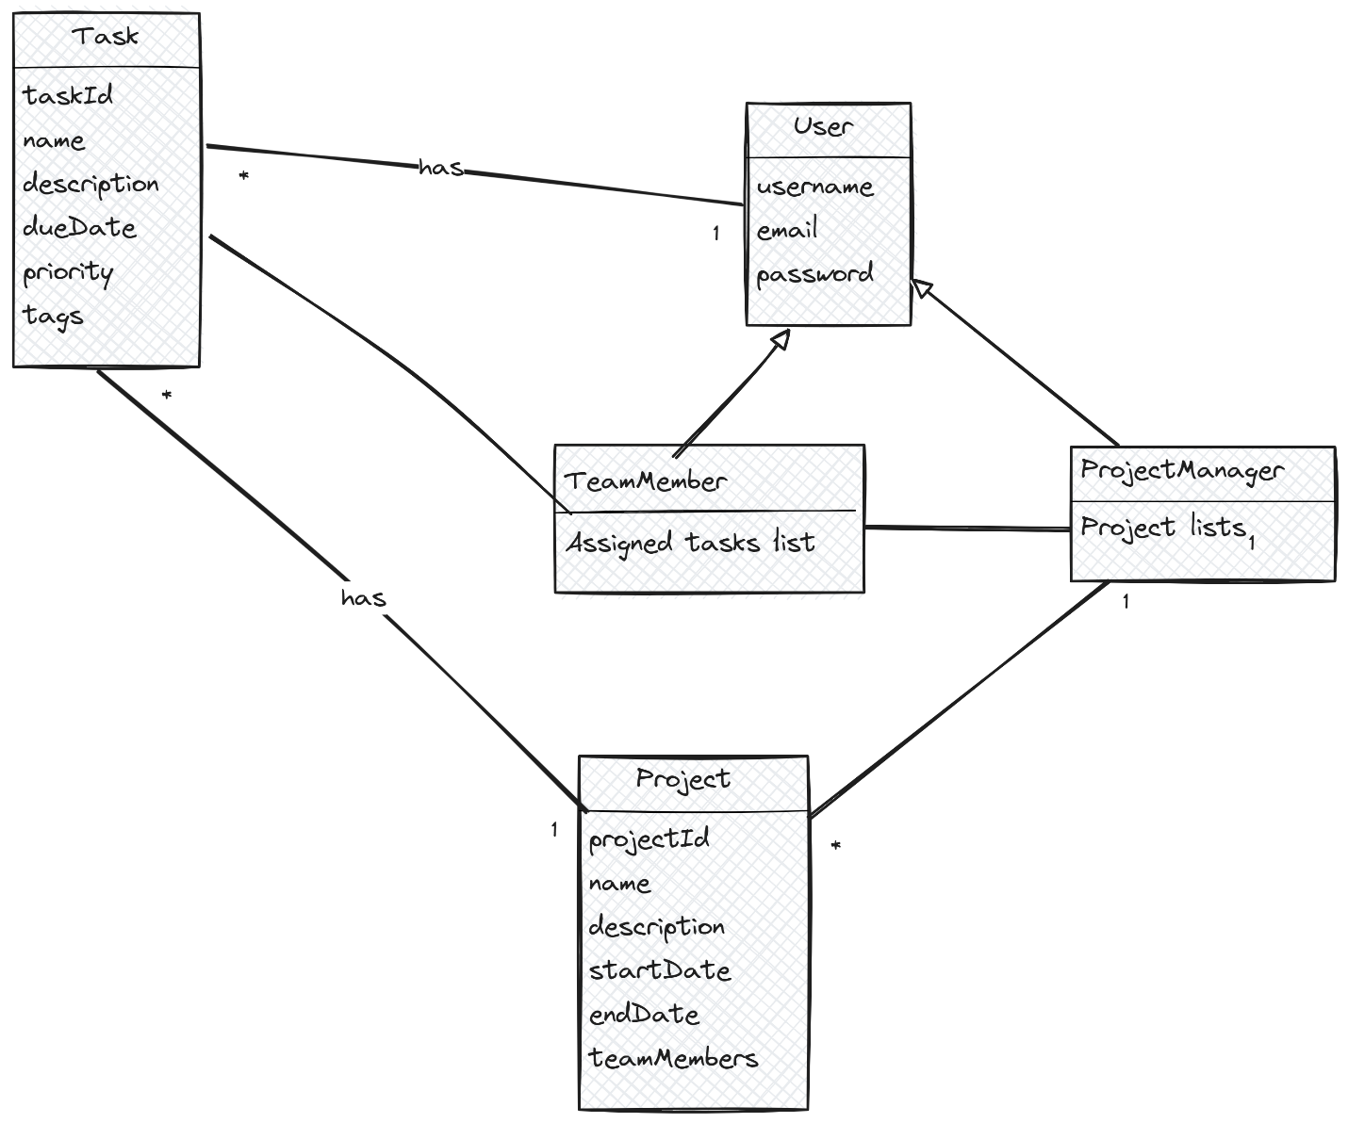

**System Sequence Diagrams:**

**Create Task**

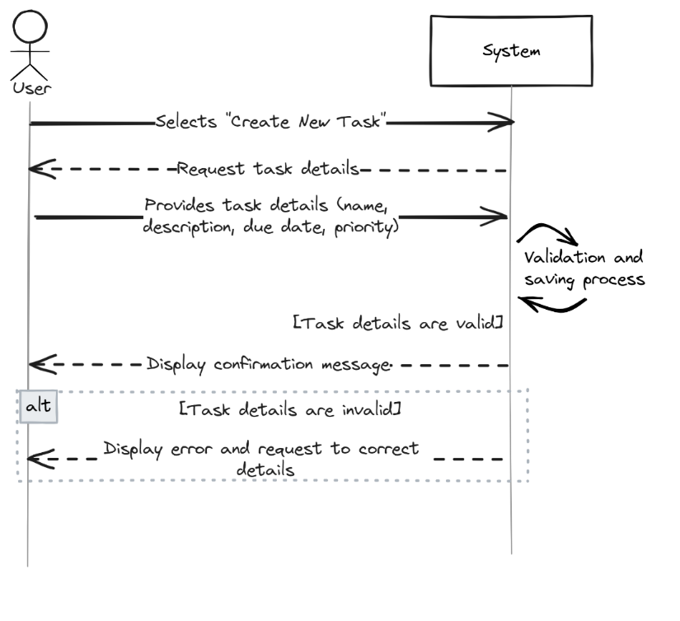

**View Task**

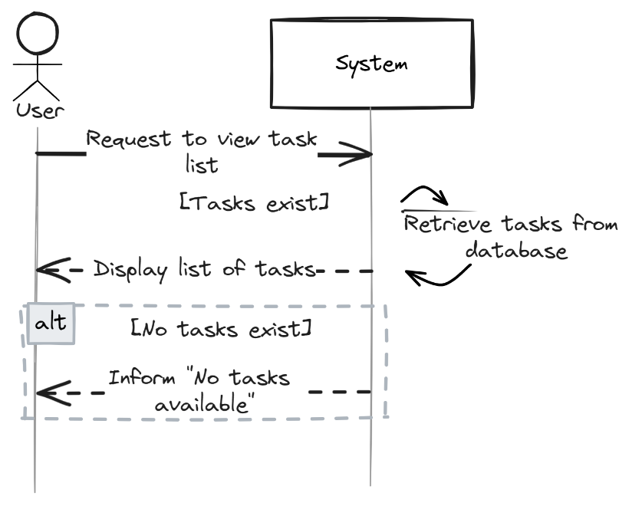

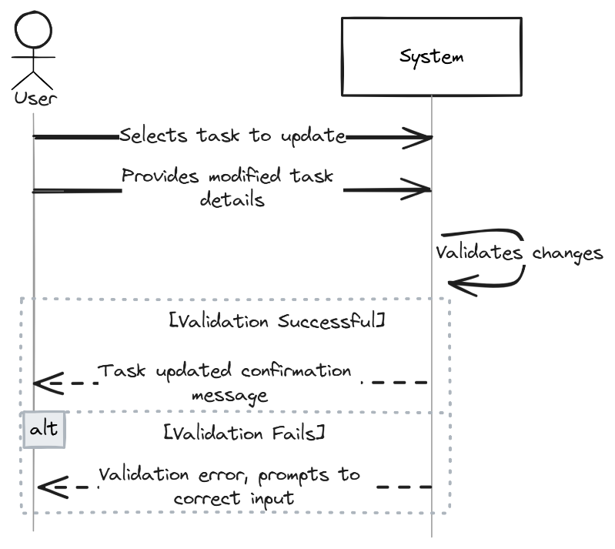

**Delete Task**

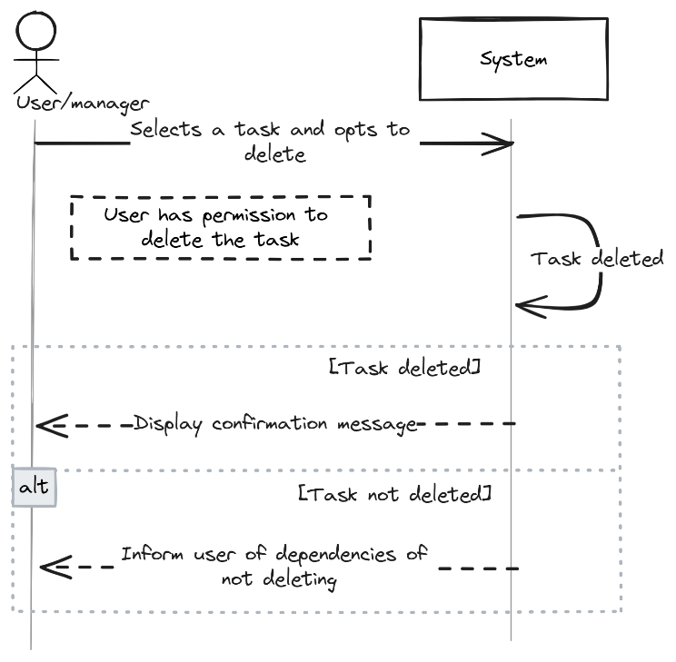

**Monitor Task**

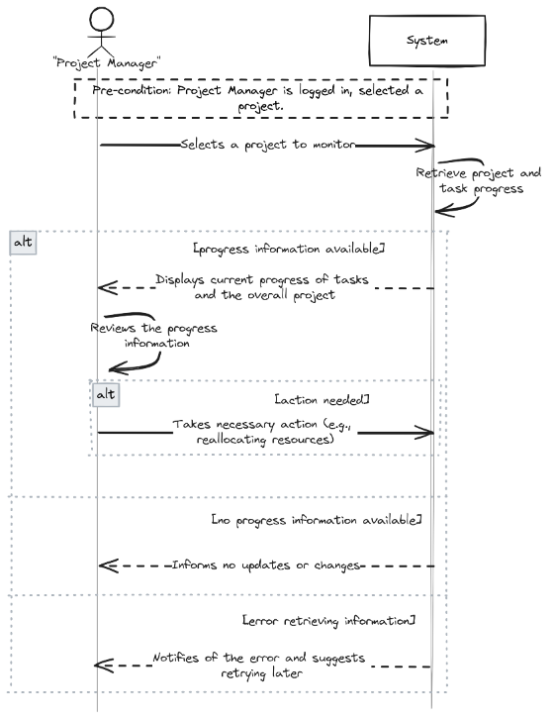

**Create Project**

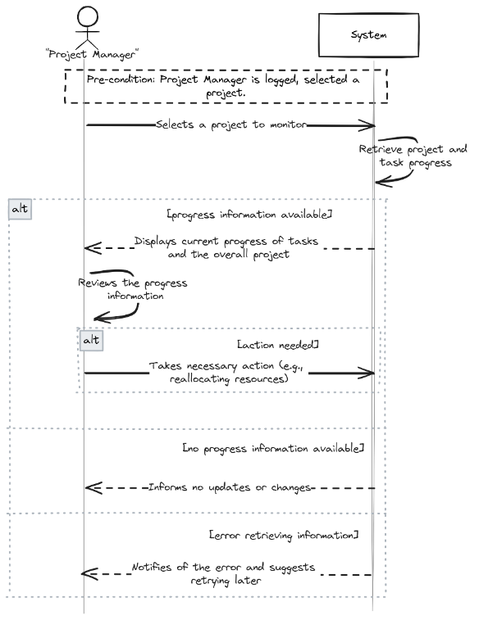

**Update Status**

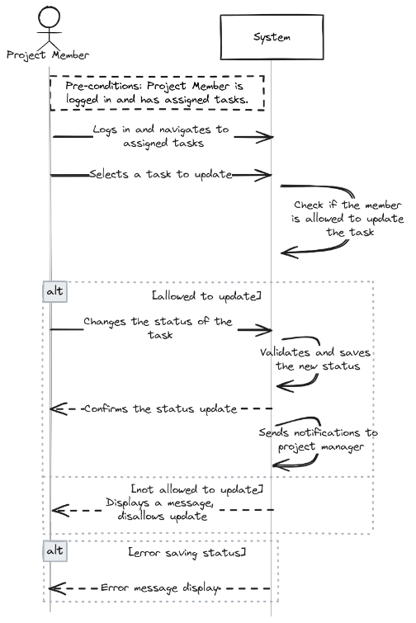

**Set Task Detail**

* 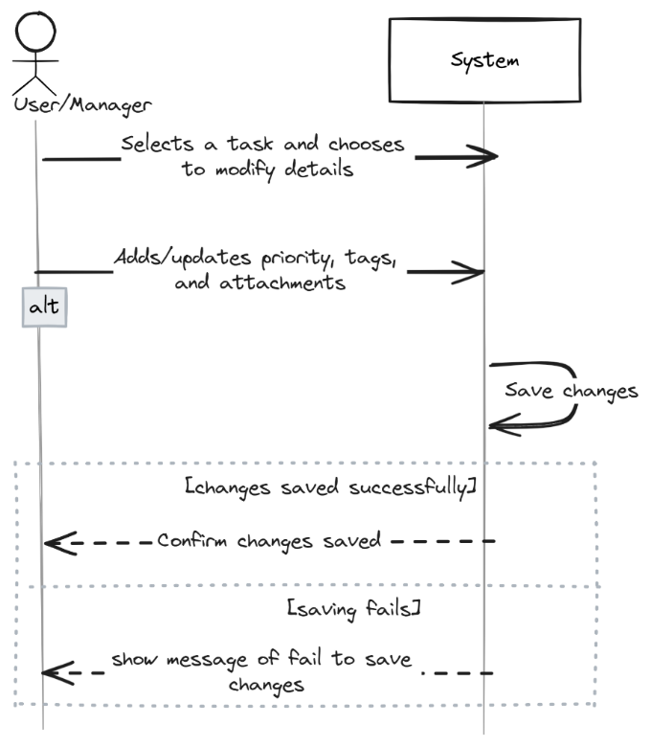

**Activity Diagrams:**

* **Create Task**
* 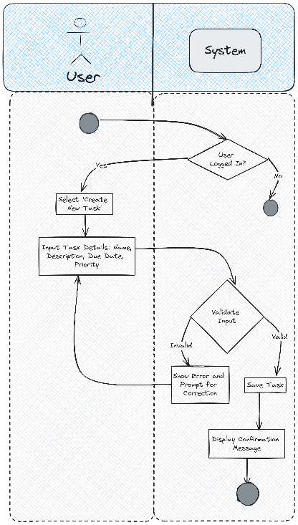

**View Task**

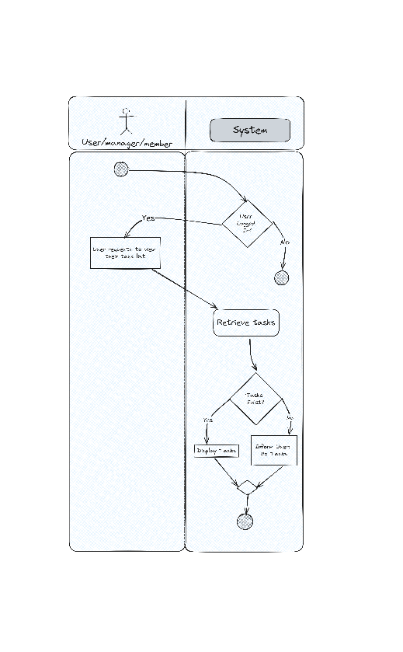

* **Update Task**

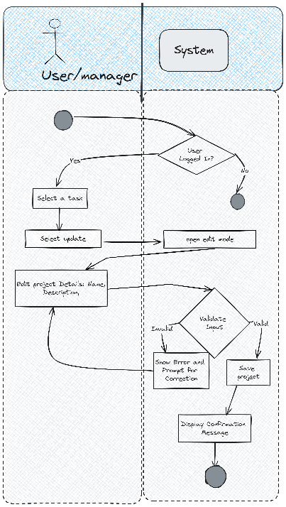

* **Delete Task**

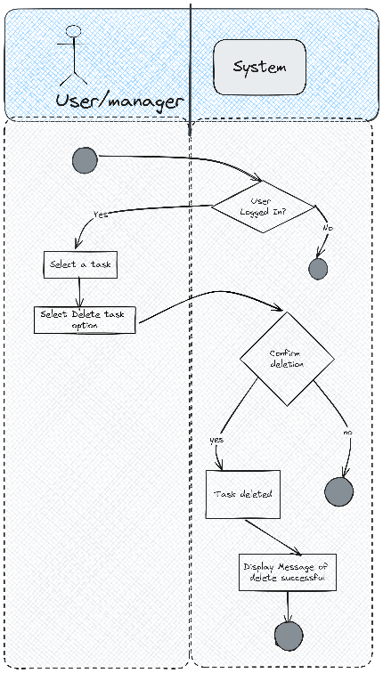

* **Monitor Task**

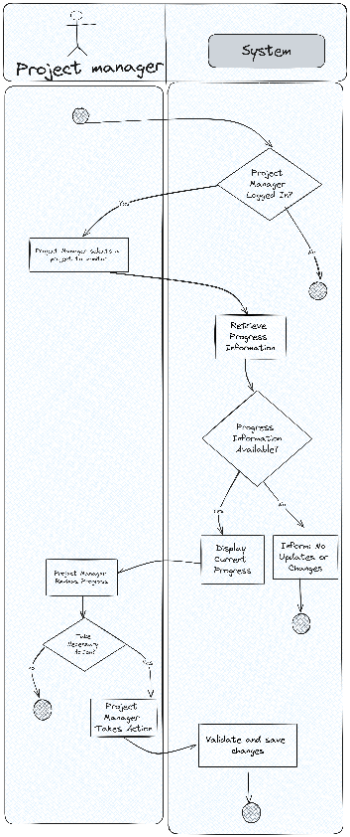

* **Create Project**

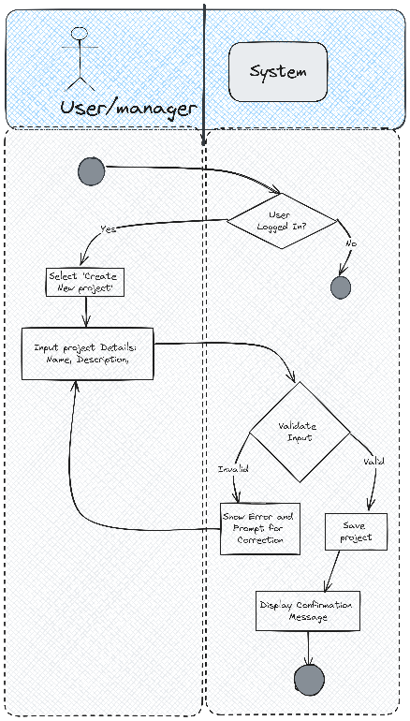

* **Update Status**

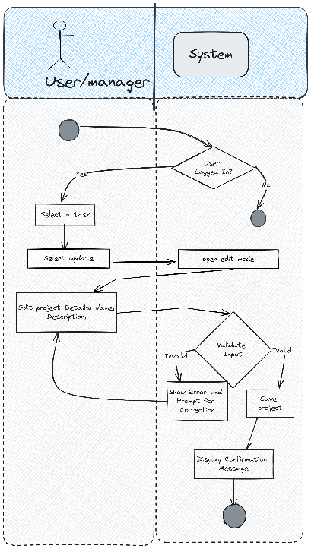

* **Set Task Detail**

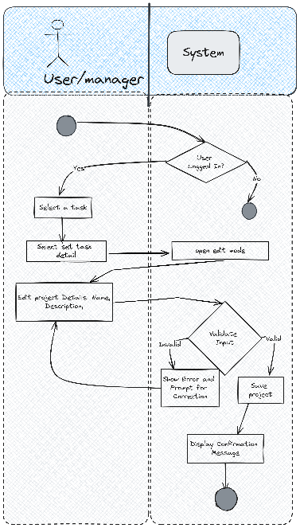

**Data Flow Diagrams:**

* **Context Diagram**

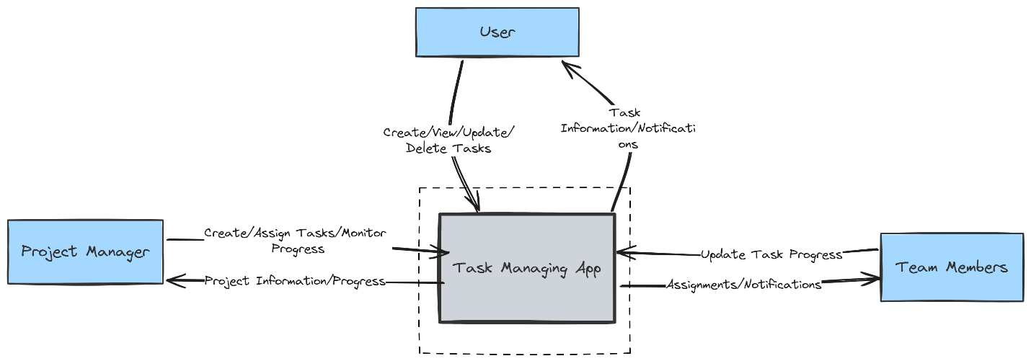

* **Level 0 DFD**

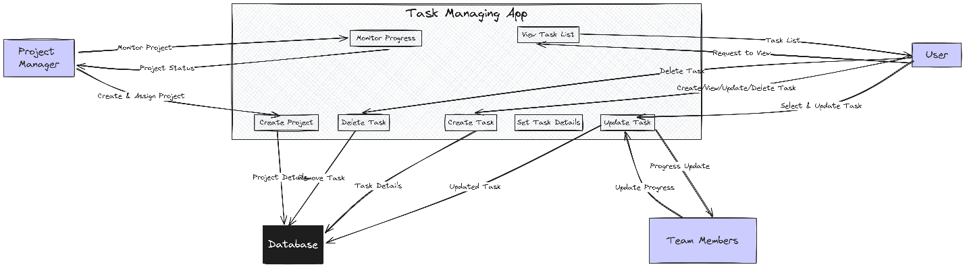

* **Level 1 DFD: Create Task**

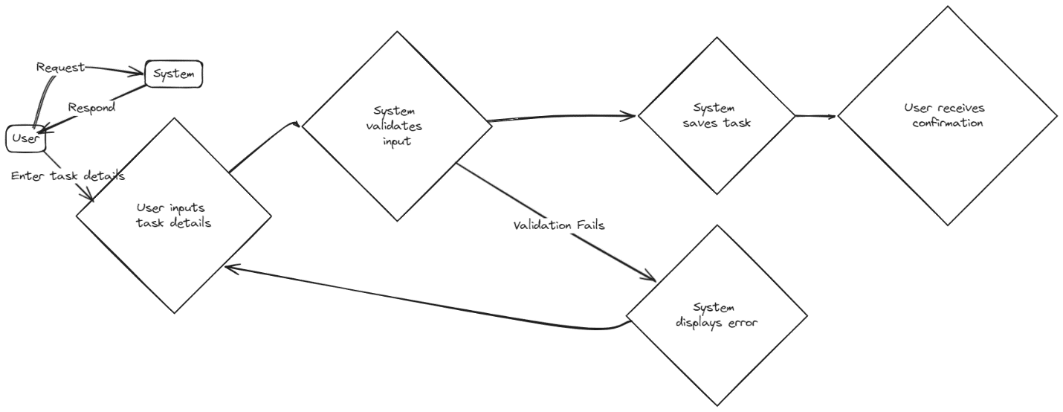

* **Level 1 DFD: View Task**

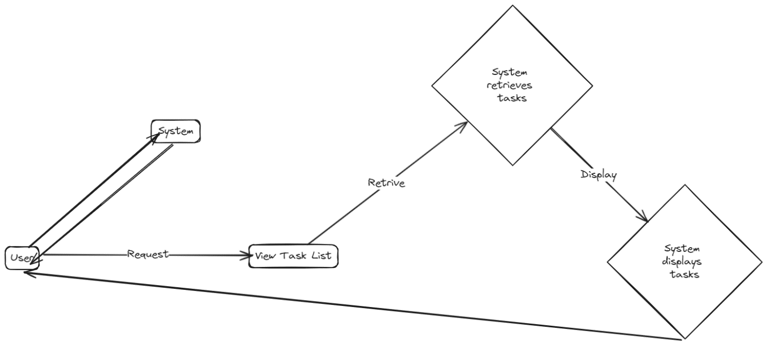

* **Level 1 DFD: Delete Task**

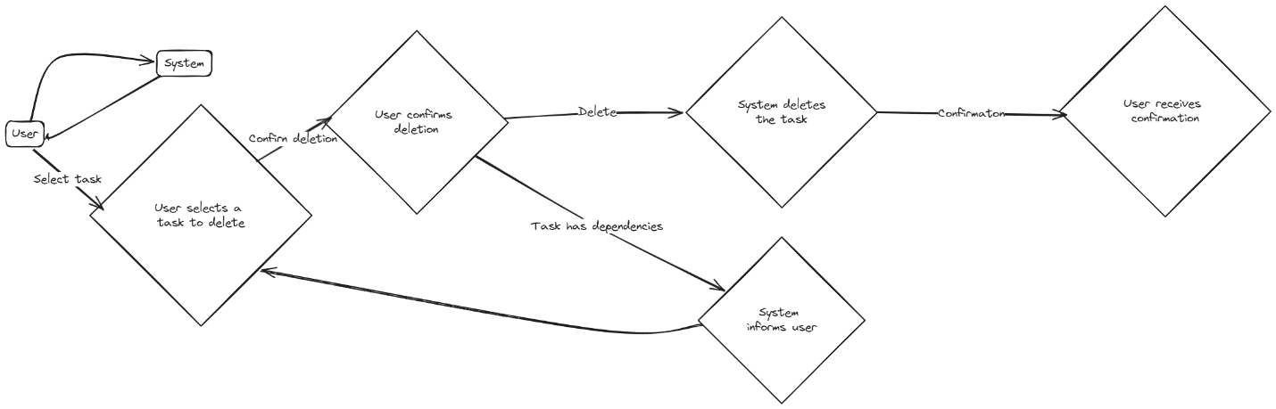

* **Level 1 DFD: Create Project**

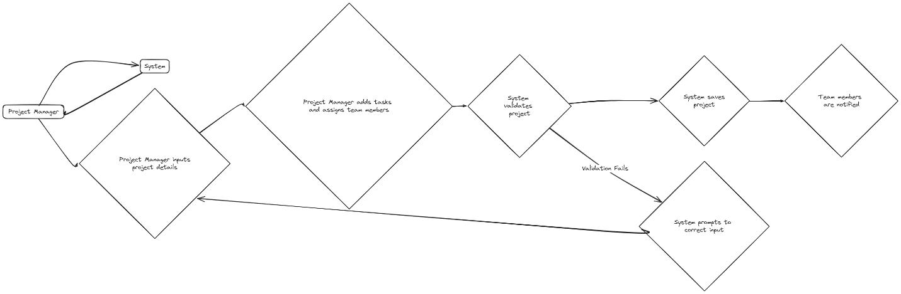

* **Level 1 DFD: Set Task Detail**

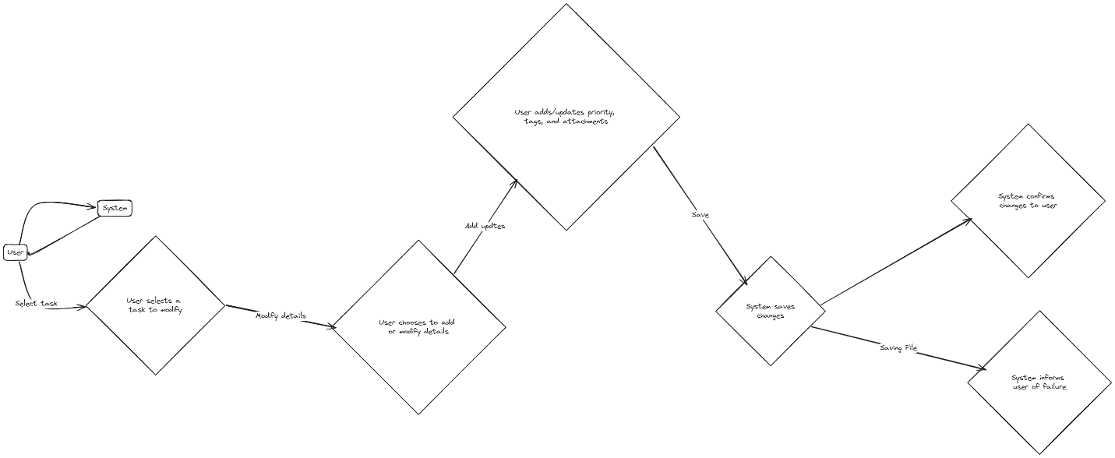

**Class diagram:**

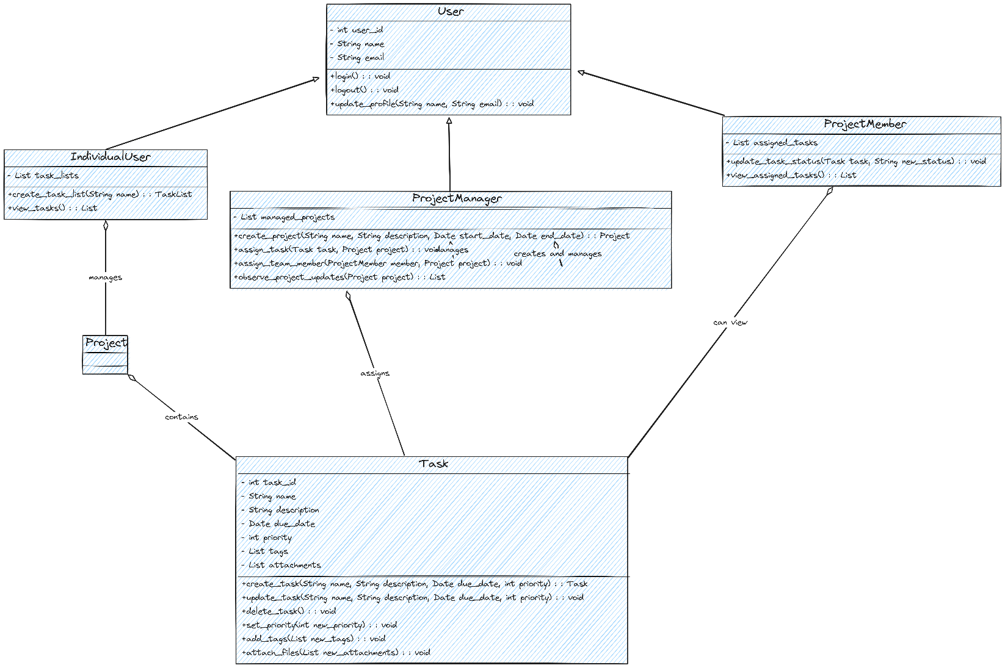

|  | **User** | **IndividualUser** | **ProjectManager** | **ProjectMember** | **Task** | **Project** |
| --- | --- | --- | --- | --- | --- | --- |
| **Manage Tasks** |  | ✔️ | ✔️ | ✔️ | ✔️ |  |
| **Create Task** |  | ✔️ | ✔️ | ✔️ | ✔️ |  |
| - Take Task name, description, due date, priority |  | ✔️ | ✔️ | ✔️ | ✔️ |  |
| - Validate input, create task, store in DB |  | ✔️ | ✔️ | ✔️ | ✔️ |  |
| - Confirmation message for successful creation |  | ✔️ | ✔️ | ✔️ | ✔️ |  |
| **View Task List** |  | ✔️ | ✔️ | ✔️ | ✔️ |  |
| - Retrieve user's tasks from database |  | ✔️ | ✔️ | ✔️ | ✔️ |  |
| - Display task details (name, due date, priority) |  | ✔️ | ✔️ | ✔️ | ✔️ |  |
| **Update Task** |  | ✔️ | ✔️ | ✔️ | ✔️ |  |
| - Select task to update, enter edit mode |  | ✔️ | ✔️ | ✔️ | ✔️ |  |
| - Validate and save the updated data |  | ✔️ | ✔️ | ✔️ | ✔️ |  |
| - Successful update message |  | ✔️ | ✔️ | ✔️ | ✔️ |  |
| **Delete Task** |  | ✔️ | ✔️ | ✔️ | ✔️ |  |
| - Select and delete task, confirm message |  | ✔️ | ✔️ | ✔️ | ✔️ |  |
| **Set Task Details** |  | ✔️ | ✔️ | ✔️ | ✔️ |  |
| - Add priority, tags, attach files |  | ✔️ | ✔️ | ✔️ | ✔️ |  |
| - Save updates, confirmation message |  | ✔️ | ✔️ | ✔️ | ✔️ |  |
| **Task Scheduling and Resource Allocation** |  |  | ✔️ |  |  | ✔️ |
| **Create Project** |  |  | ✔️ |  |  | ✔️ |
| - Project manager creates project |  |  | ✔️ |  |  | ✔️ |
| - Define project details |  |  | ✔️ |  |  | ✔️ |
| - Assign start and end dates to tasks |  |  | ✔️ |  |  | ✔️ |
| - Assign tasks to team members |  |  | ✔️ |  |  | ✔️ |
| - Team members receive notifications |  |  | ✔️ | ✔️ |  |  |
| **Monitor Progress** |  |  | ✔️ | ✔️ |  |  |
| - Team members update task progress |  |  |  | ✔️ |  |  |
| - Project manager monitors overall progress |  |  | ✔️ |  |  |  |

## Sequence Diagrams

### **Create Task Module:**

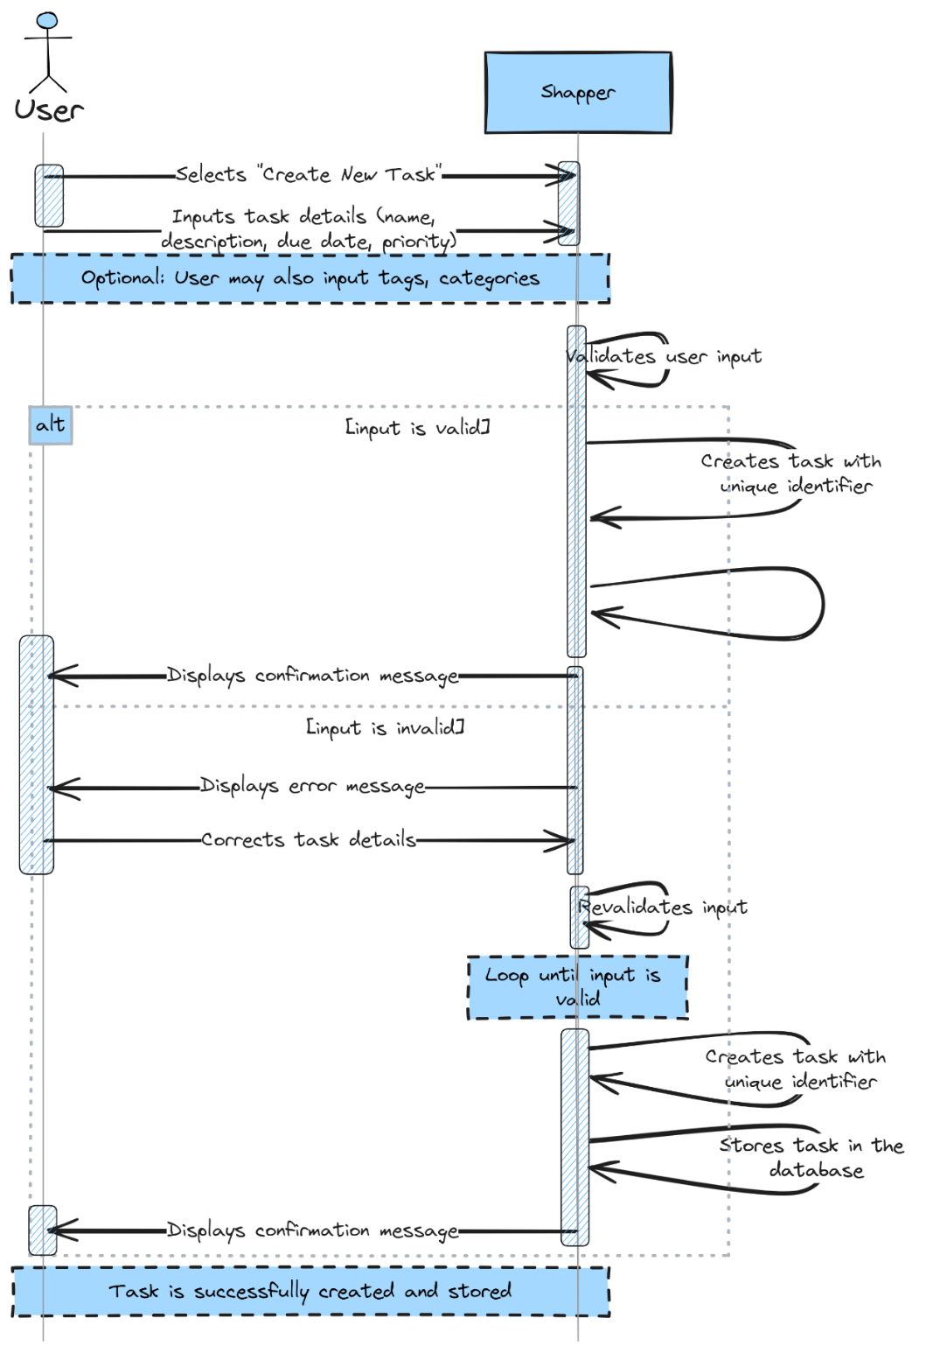

### **Update Task Module**

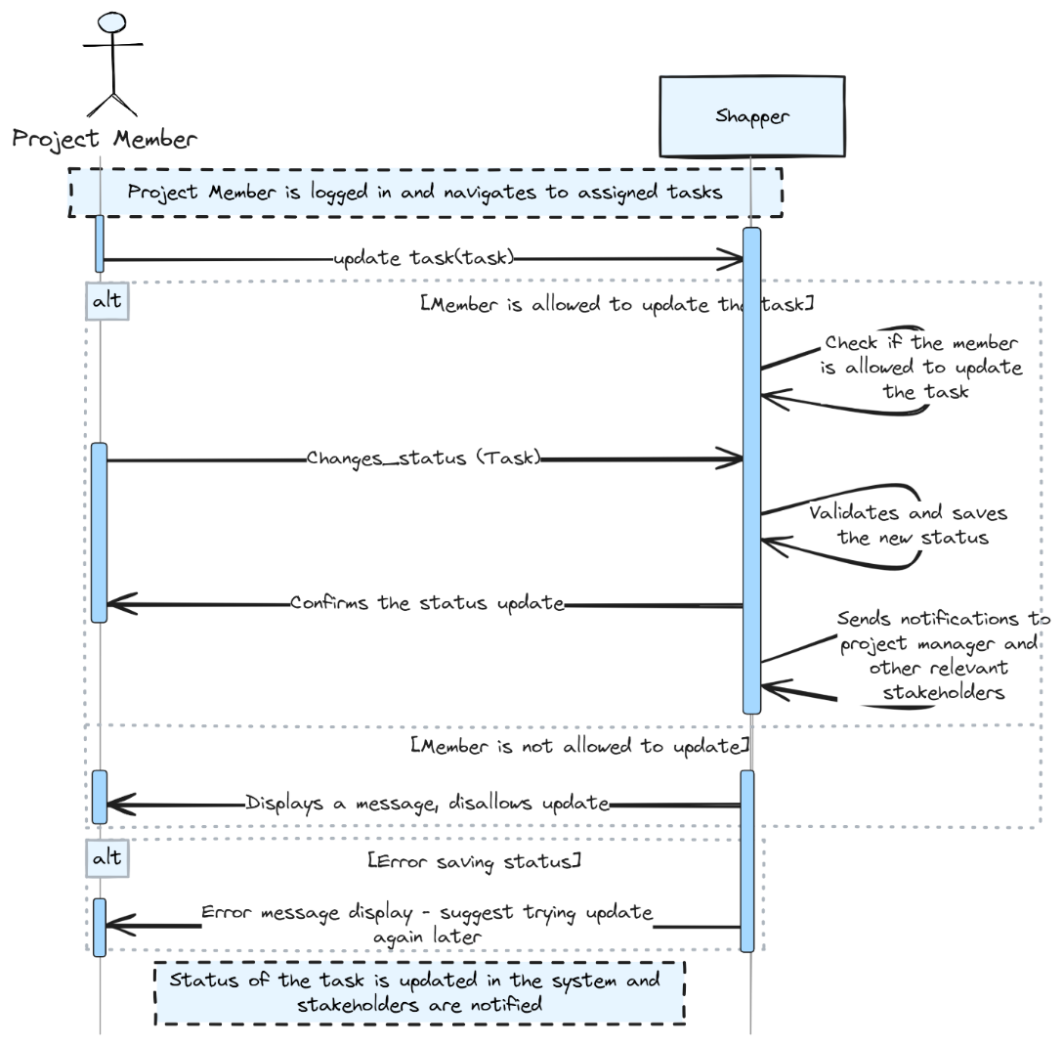

### **View Task Module**

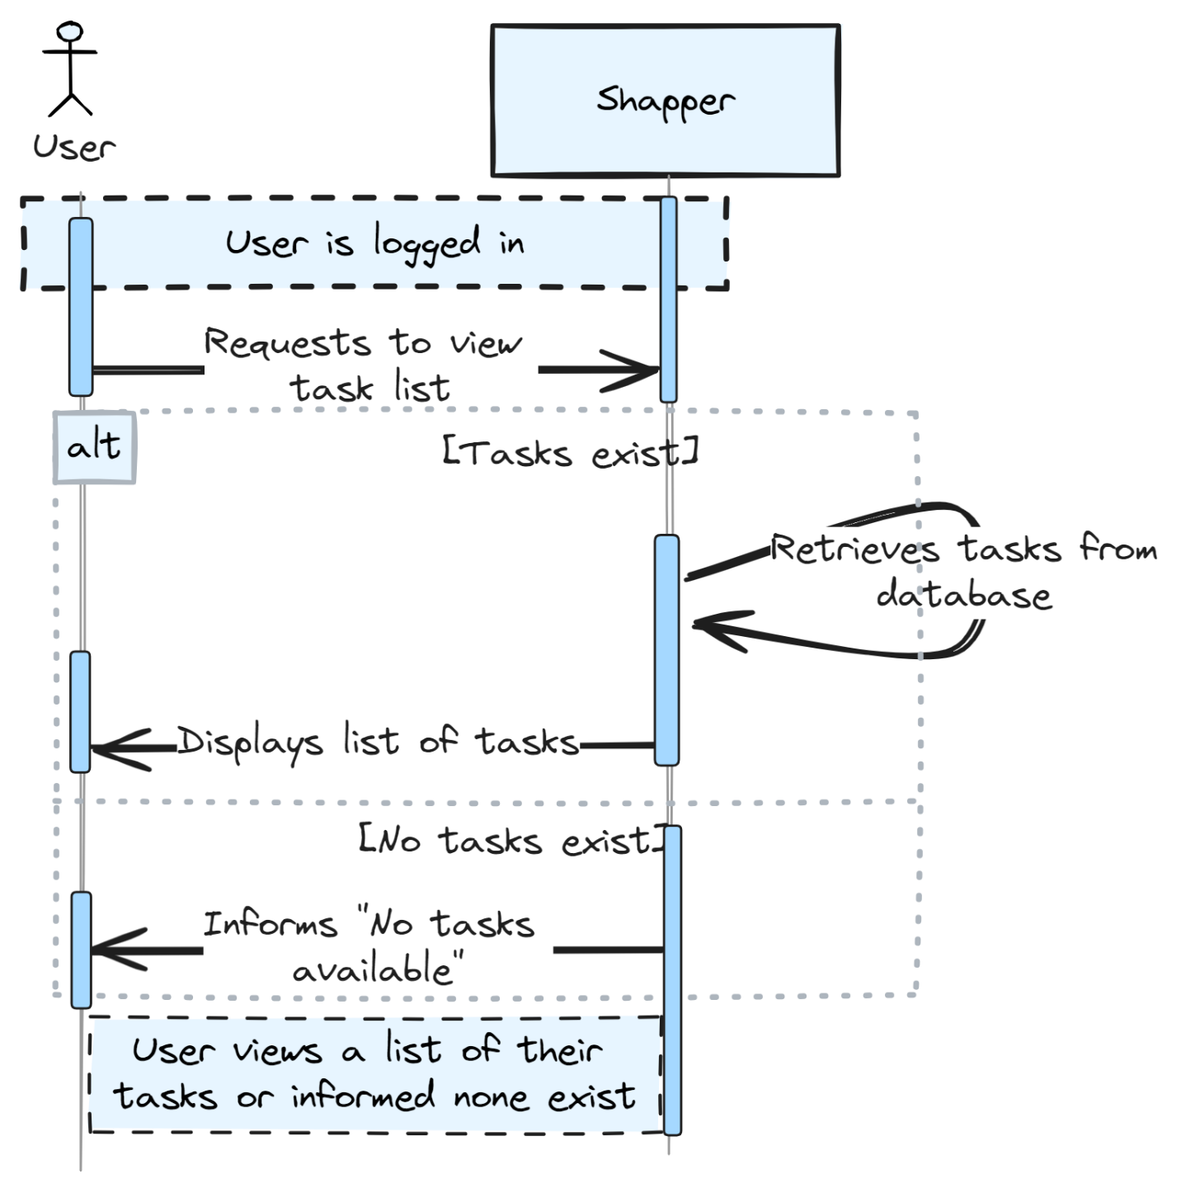

### **Delete Task Module**

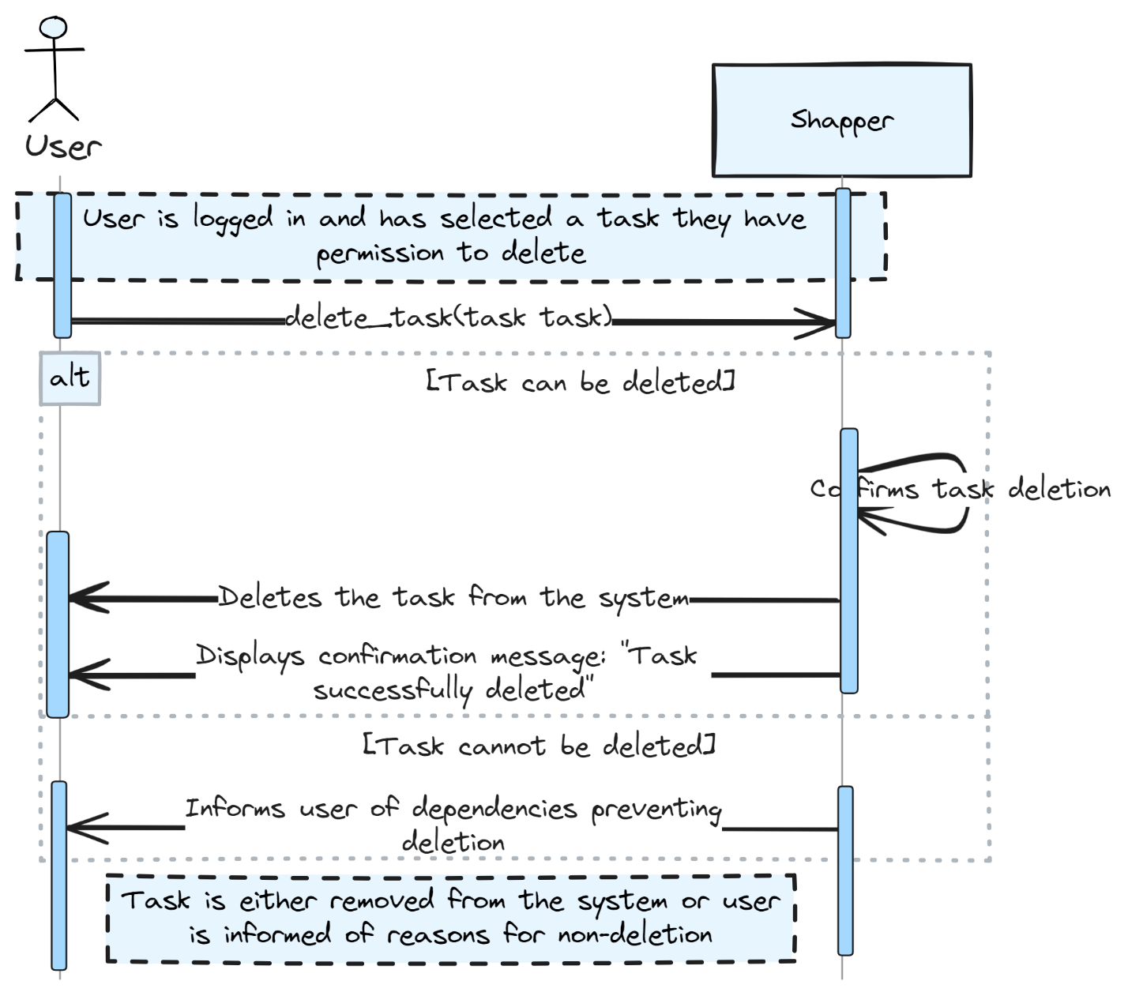

### **Monitor Task Module**

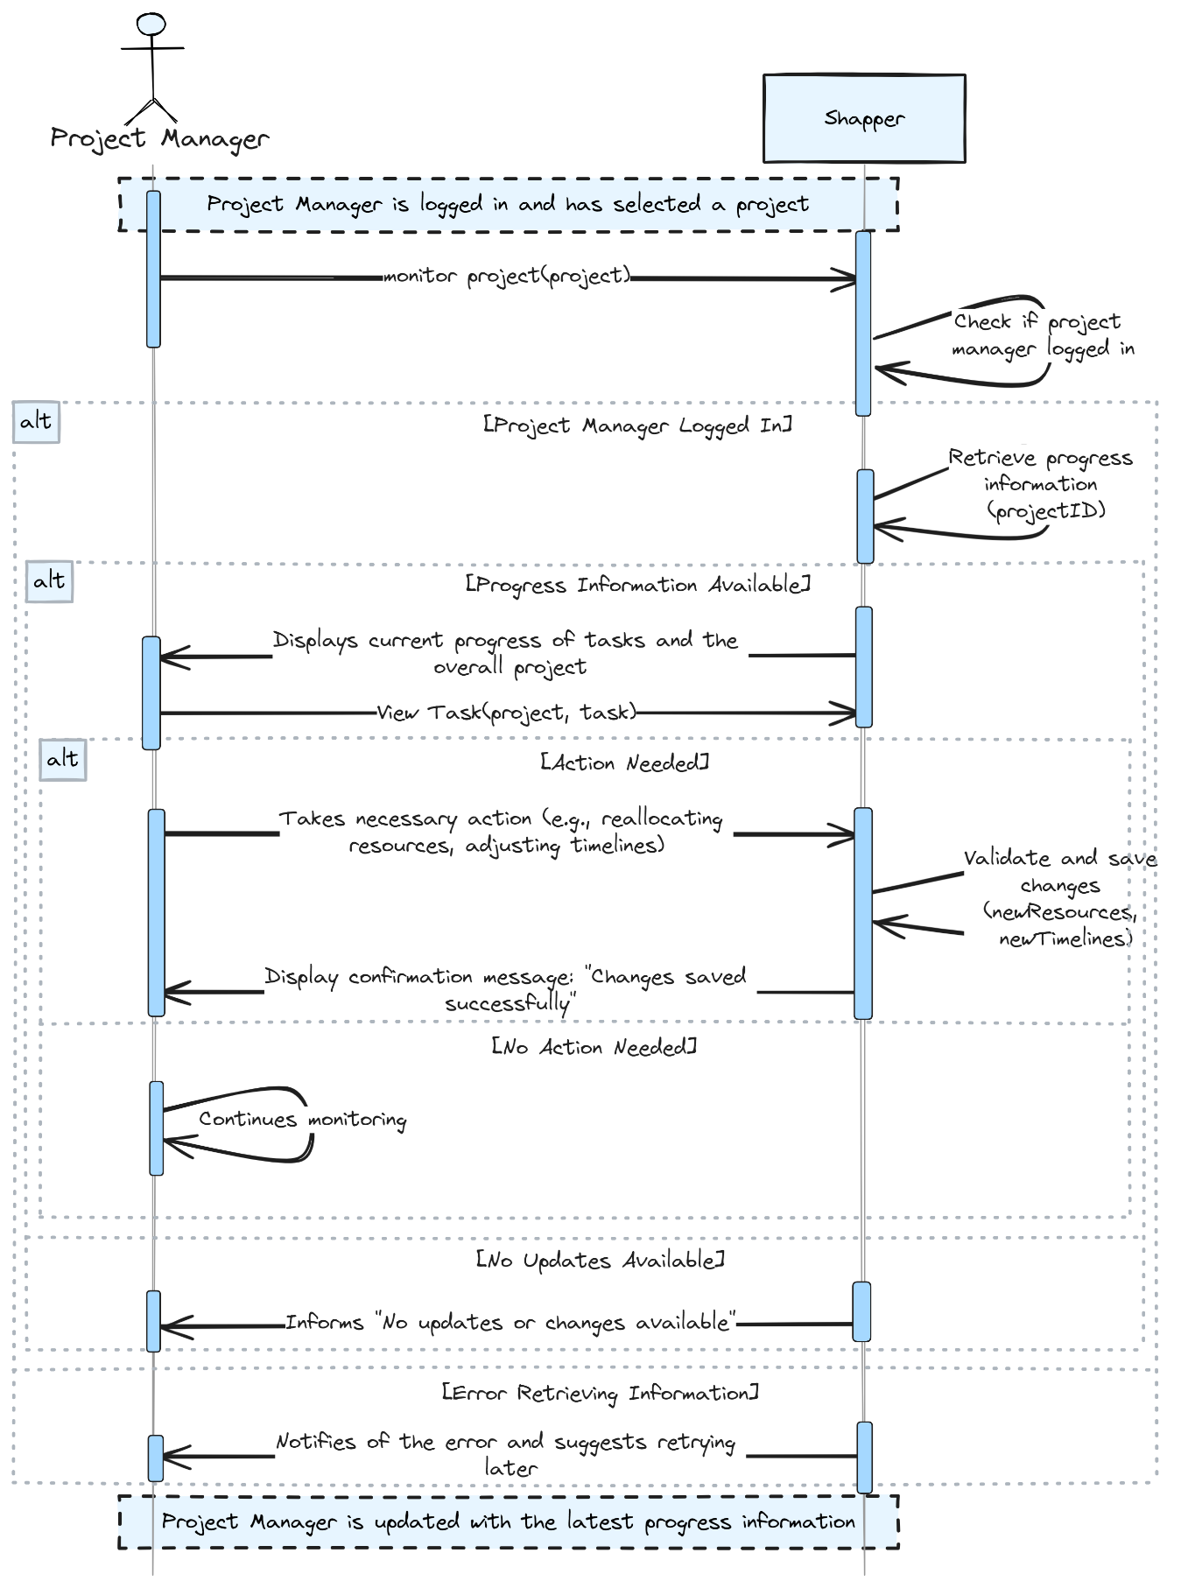

### **Update Status Module**

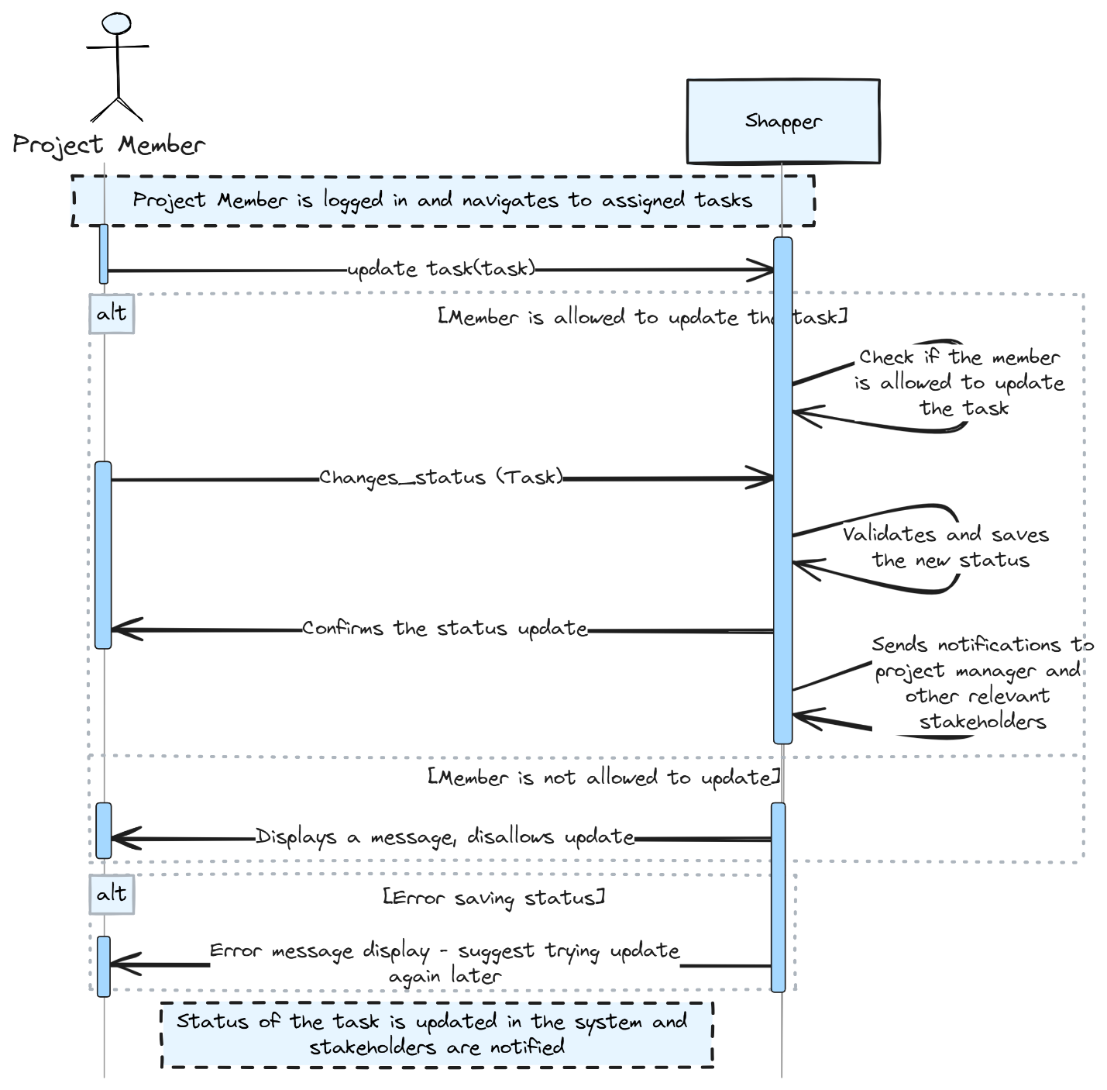

### **Create Project Module**

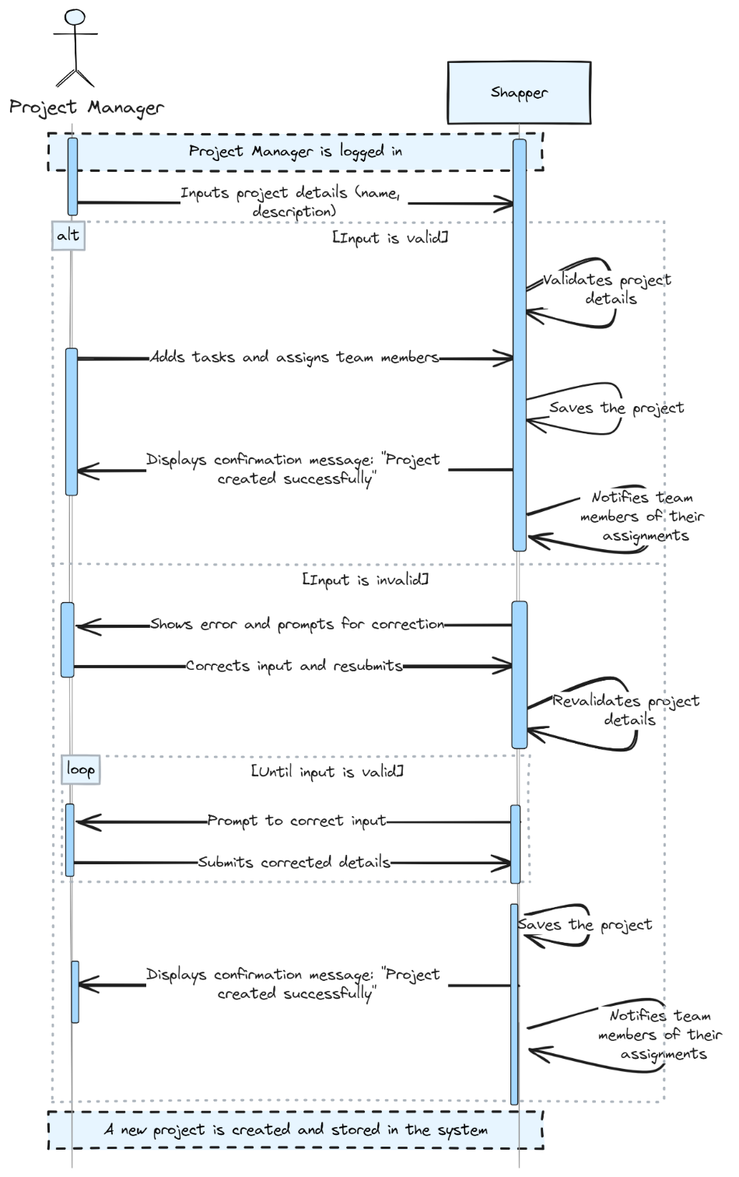

### **Set Details Module:**

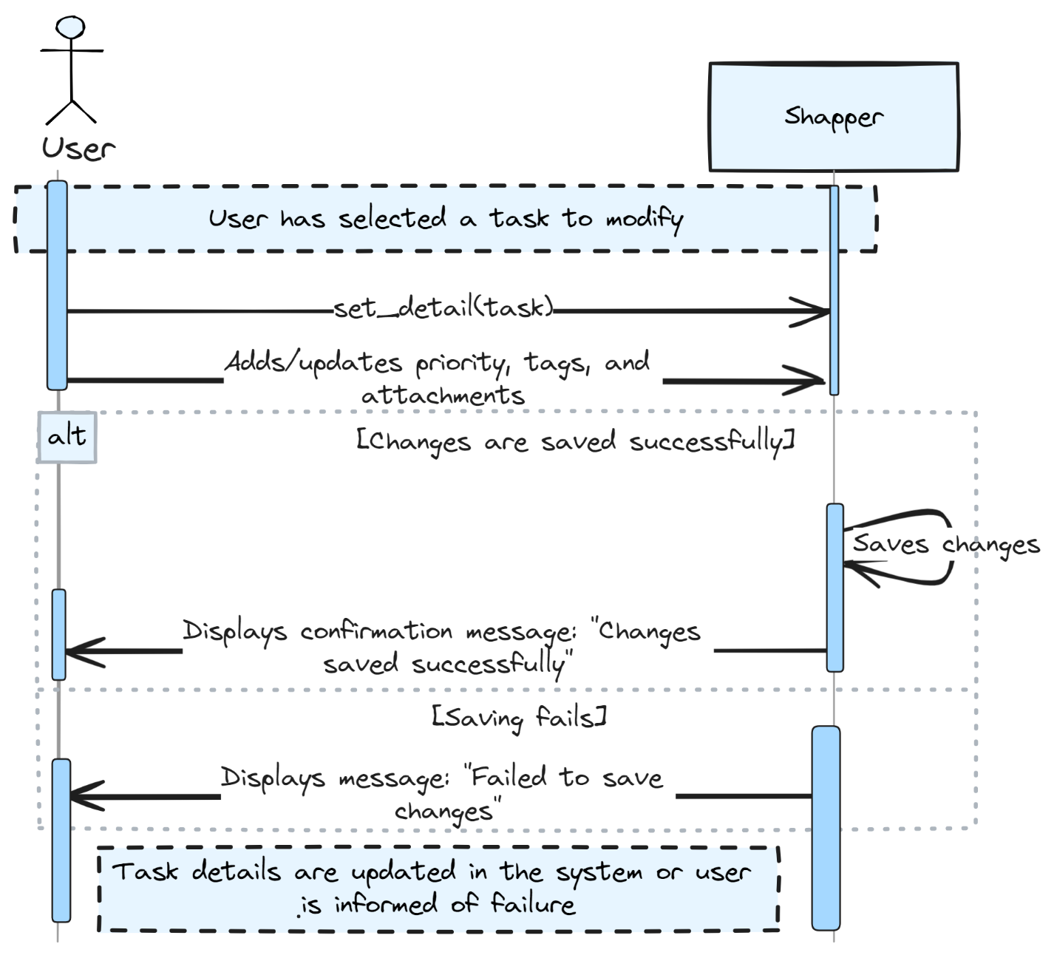

## Component Diagram

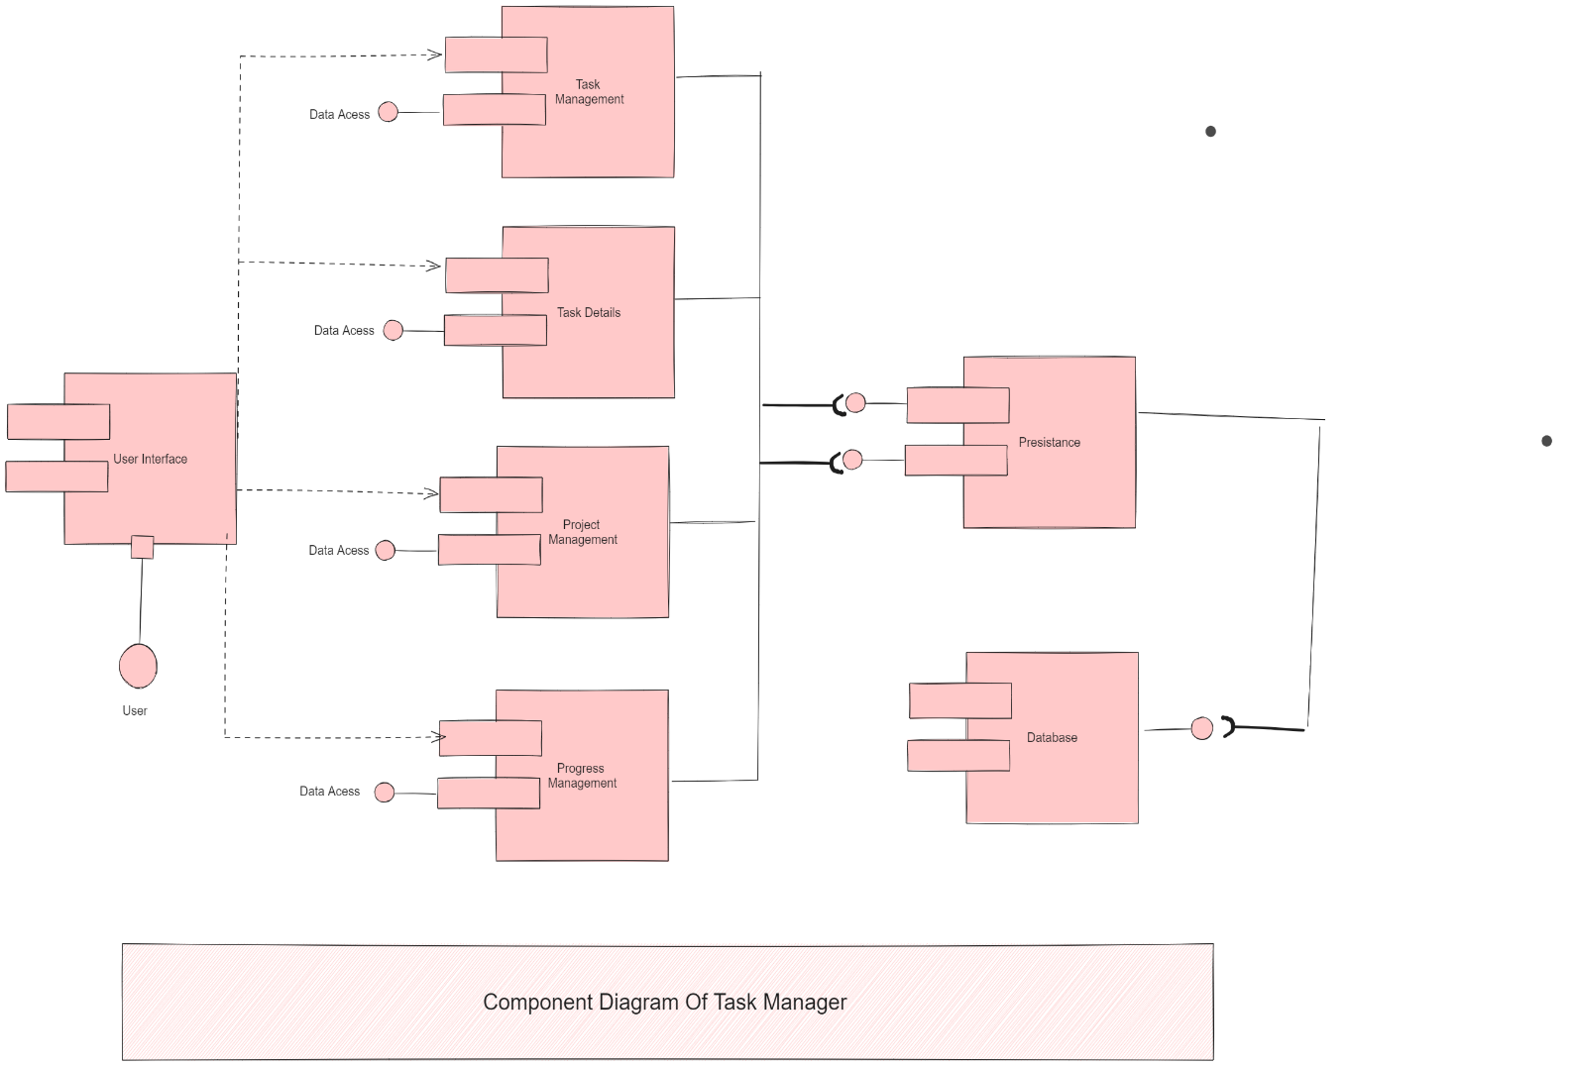

## Packages Diagram

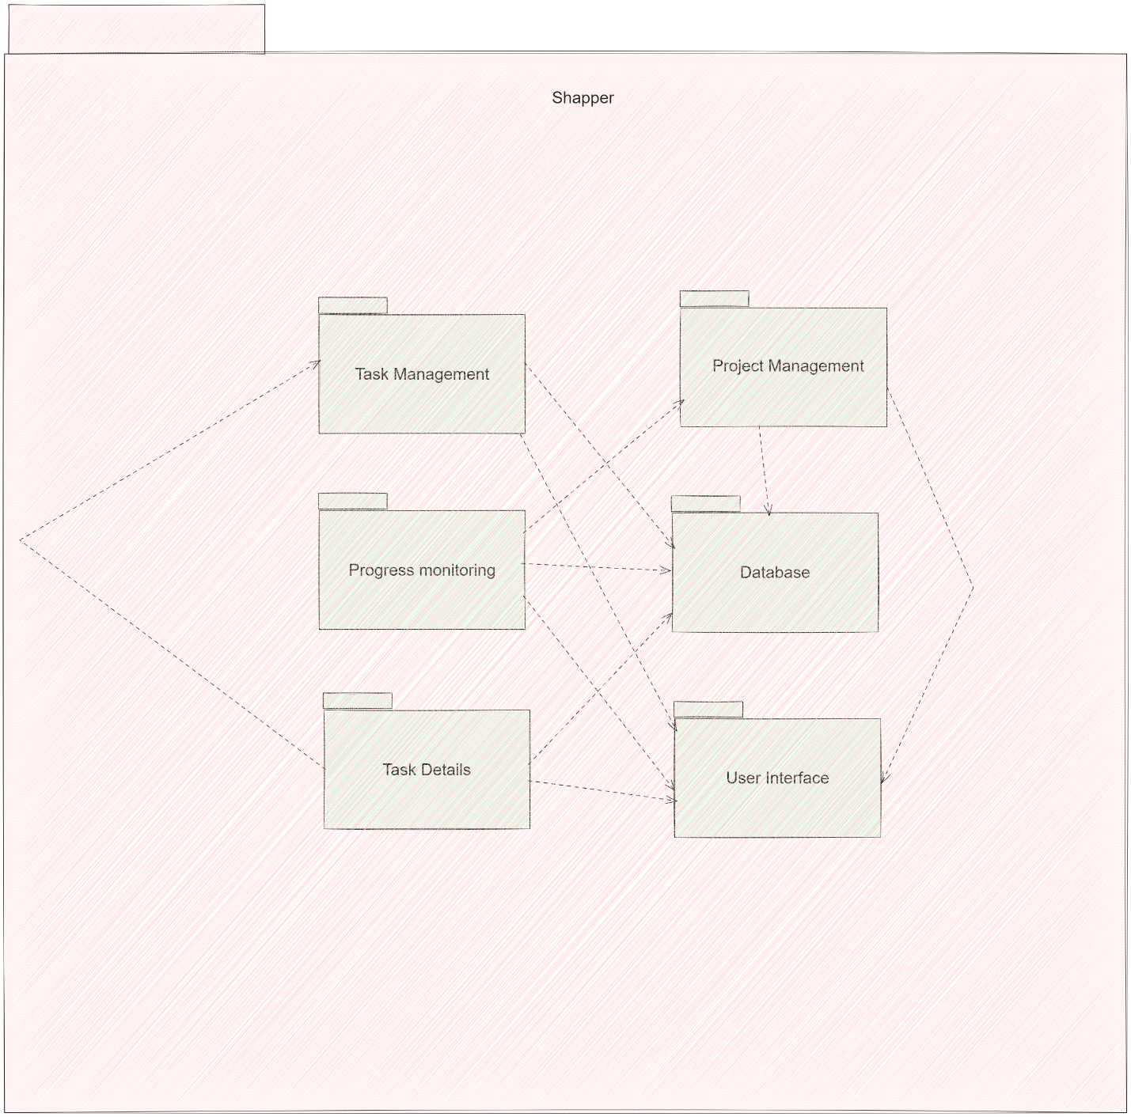

## Deployment Diagram

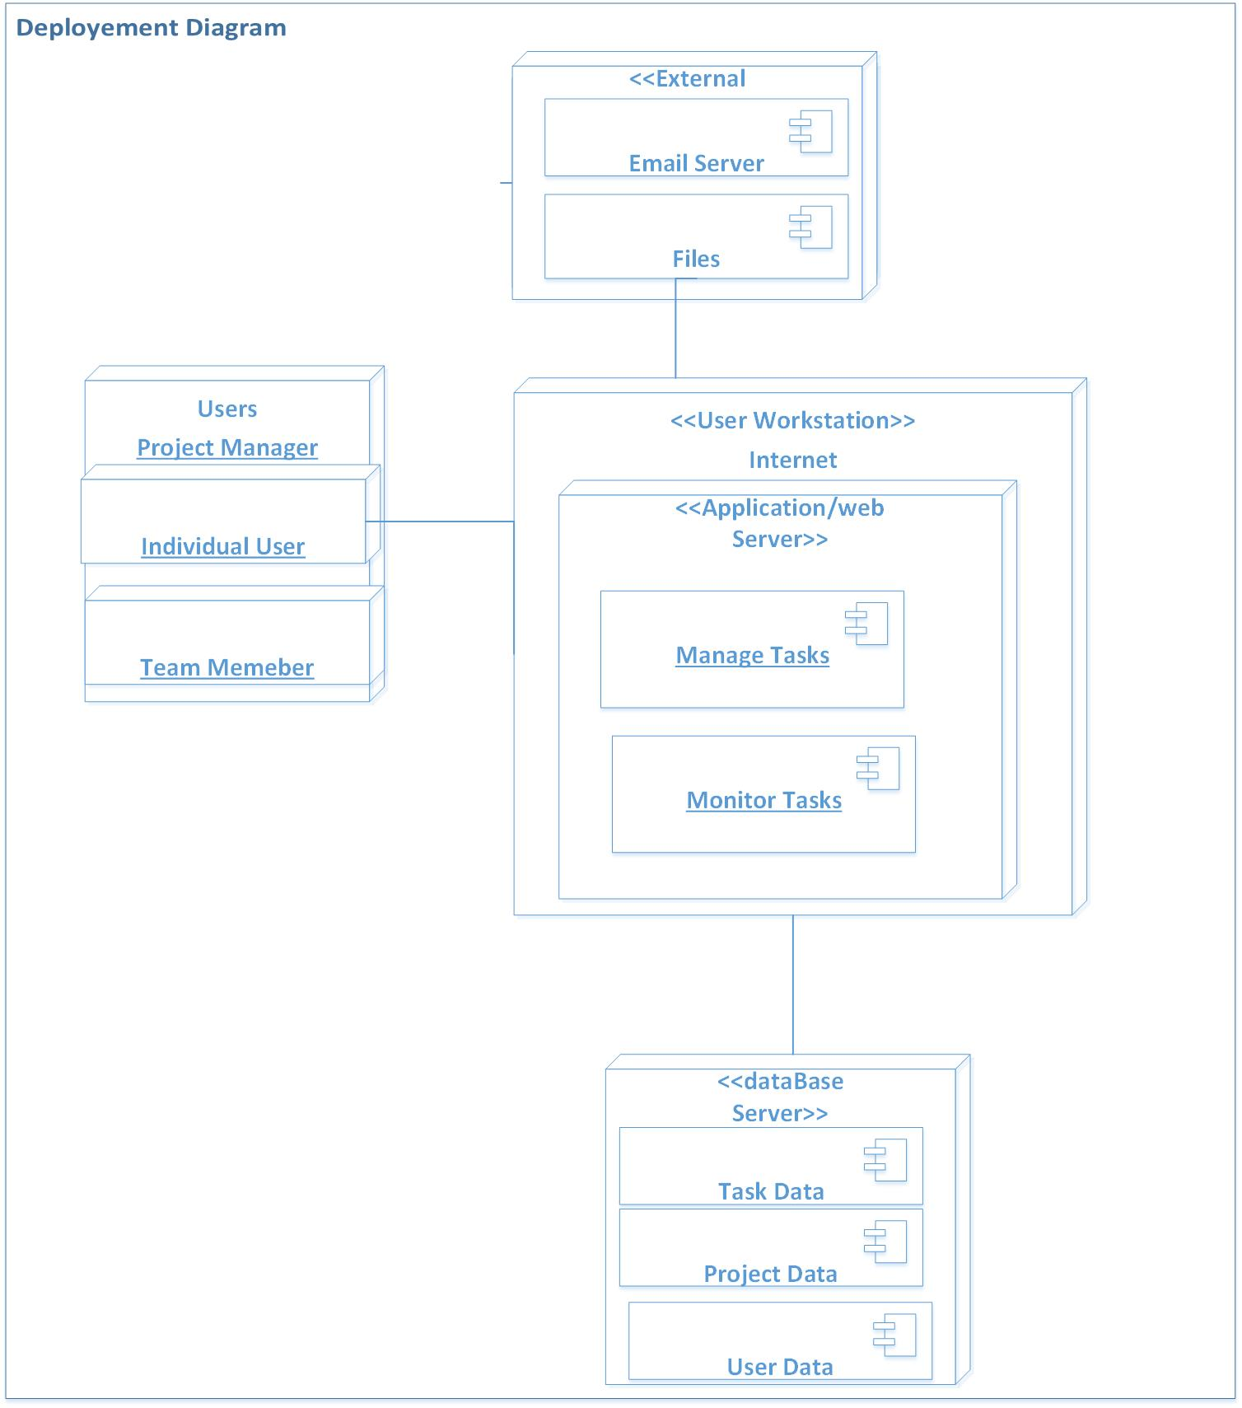

## Conclusion

In conclusion, Phase 3 of the Shapper task management app's software design architecture has successfully outlined the class structure, behavioral flow, deployment strategy, and component organization for various modules like create task, update task, view task, delete task, monitor task, update status, create project, and assign task. This phase is fundamental in ensuring the scalability, maintainability, and efficient functioning of the Shapper system as it progresses towards development and implementation stages.